The object of this school is the regular and progressive instruction of the artilleryman in his
duties at and connected with the piece, from the period of his joining as a recruit.
This instruction is given by the non-commissioned officers, under the supervision of the chiefs of sections.
The instructor should never require a movement to be performed until it is exactly explained and
executed by himself. It should be left to the recruit to take the positions, and execute the movements
directed, and he should be touched only to rectify mistakes arising from want of intelligence.
Each movement should be perfectly understood before passing to another. After they have been
properly executed in the order laid down, the instructor no longer confines himself to that order.
The instructor allows the men to rest at intervals during drill, and for this purpose he commands:
REST. At this command the recruit is no longer required to preserve immobility. At the
command: ATTENTION, the man takes his position, and remains motionless.
Great patience and the utmost precision are necessary on the part of the instructor. He should
especially endeavor to excite a spirited and active deportment at every military exercise, and above
all not to disgust the men by too long an application to any one point in the drill.
ELEMENTARY INSTRUCTION.
This part is taught to each recruit individually, or at most to four at a time. In the latter case,
they are placed in the same line, one yard from each other, without being required to align themselves.
POSITION OF THE CANNONEER DISMOUNTED.
The heels on the same line, and as near each other as the conformation of the man will permit;
the feet turned out equally, and forming with each other something less than a right angle; the knees
straight; body erect on the hips, inclining a little forward; shoulders square; arms hanging naturally,
with the palms of the hands turned a little to the front; head erect; chin slightly drawn in; eyes to the
front; the position of the whole body without constraint; when the sabre is worn, the left hand hangs
by the side and over it.

EYES RIGHT----EYES LEFT.
The instructor commands:
1. Eyes---RIGHT. 2. FRONT.
At the command RIGHT, turn the head gently to the right, so that the inner corner of the left eye may be on a
line with the buttons of the jacket, the chin well drawn in. At the command FRONT, turn the head gently to the front.
The command Eyes---LEFT is executed on the same principles.

FACINGS.
TO THE RIGHT OR LEFT, the instructor commands:
1. Cannoneers right, (or left). 2. FACE.
At the command FACE, raise the right foot slightly, turn on the left heel, and replace the right foot
by the side of the left.
TO THE REAR. The instructor commands:
1. Cannoneers, rear. 2. FACE.
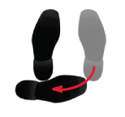
At the command rear, make a half face to the right, turning on the left heel; place the right foot
square behind the left, the hollow of it opposite to and three inches from the left heel. At the
command FACE, turn on both heels to face the rear, and bring the right foot by the side of the left.
HALF-FACE. The commands are:
1. Cannoneers right (or left) oblique. 2. FACE.
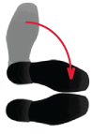
At the command FACE, raise the right foot a little, turn upon the left heel, making a half-face, and
replace the right foot by the side of the left. The instructor will take care that in executing the facings
the position of the body is not deranged.

MARCHING.
The length of the marching step is 28 inches; its quickness at the rate of 110 steps a minute. For the
elementary instruction of recruits, the quickness of the step is reduced to 90 a minute. When the
command Double-quick is given, it is increased to 165. To explain the principles and mechanism of
the step, the instructor, placing himself 8 or 10 yards in front of and facing the men, describes and
slowly executes it himself. He then commands:
1. Cannoneers, forward. 2. MARCH.
At the command forward, throw the weight of the body on the right leg. At the command MARCH,
carry the left foot briskly forward 28 inches, the toe and little depressed, and, as well as the knee,
turned slightly out; the upper part of the body including slightly forward; plant the left foot without
a shock on the ground, throwing the whole weight of the body upon it; carry forward the right
leg smartly and evenly, the foot near the ground; plant it at the same distance, and in the manner
described for the left foot, and continue the march, keeping the face and shoulders square to the front.
The instructor marks the cadence of the step, from time to time, by the commands right or left, or
both, given at the moment that the foot indicated should be planted.
The instructor commands:
1. Cannoneers. 2. HALT.
At the command HALT, which should be given as one foot comes to the ground, bring the one in rear
to the side of it without shock.

TO MARCH BACKWARDS.
The instructor commands:
1. Cannoneers, backwards. 2. MARCH.
At the command MARCH, carry the left foot 14 inches to the rear, then bring the right foot likewise
to the rear of it, and so on, successively, until the command:
1. Cannoneers. 2. HALT.
At the command HALT, bring the foot which is in the front by the side of the other.
The instructor requires only a few steps to be taken. He observes that the men step straight to
the rear; that they do not hollow the small of the back by throwing back the shoulders; and that
they always preserve the equilibrium and the position of the body.

TO MARK TIME WHEN MARCHING
The instructor commands:
1. Mark-time. 2. MARCH.
At the command MARCH, bring the heels by the side of each other, and mark the cadence of the
step by raising the feet alternately, without advancing them, until the commands are given:
1. Forward. 2. MARCH.
At the command MARCH, given as one foot is coming to the ground, the cannoneers resume the
step of 28 inches with the other.

TO CHANGE STEP.
The instructor commands:
1. Change step. 2. MARCH.
At the command MARCH, given at the moment one foot is coming to the ground, bring the other to its side,
and step off again with the first. The men are thus taught to take the step when they have lost it.

TO FACE WHEN MARCHING.
TO THE RIGHT. --- The instructor commands:
1. Cannoneers, by the right flank. 2. MARCH.
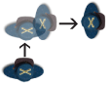
At the command MARCH, given at the moment the left foot is coming to the ground, turn the body
to the right, and step off with the right foot in the new direction, without losing the cadence of the step.

TO THE LEFT. --- The instructor commands:
1. Cannoneers, by the left flank. 2. MARCH.
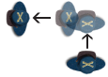
At the command MARCH, which is given as the right foot is coming to the ground, turn the body to
the left, and step off, with the left foot.

TO THE REAR. --- The instructor commands:
1. Cannoneers, to the rear. 2. MARCH.
Which is executed as directed for facing to the right, excepting hat the body is turned to face to
the rear instead of the right.

HALF FACE TO THE RIGHT OR LEFT. --- The instructor commands:
1. Cannoneers, right (or left) oblique. 2. MARCH.
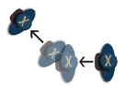
At the command MARCH, make a half-face to the right, (or left) and step off in the new direction, with
the leg on the side towards which the turn is made.

TO RESUME THE PRIMITIVE DIRECTION. --- The instructor commands:
FORWARD.
At this command make a half face so as to move in the original direction, and march straight to the
front in the manner prescribed for the oblique.

The cannoneers of a piece, when united for the service of the gun, or for the preliminary instruction,
constitute a DETACHMENT, which is composed ordinarily of eight men, commanded by the gunner.
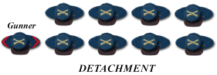

A RANK is composed of men abreast.
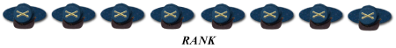

A FILE of men placed one behind the other.
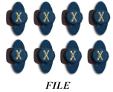
The cannoneers fall in two ranks (FILE by DETACHMENT), 18 inches between the ranks, elbows
slightly touching, and in such manner that they may be told off to the duties at the piece for which
they are best fitted. This, of course does not apply to recruits, each of whom must be taught the
duties of every number (gun positions) under all circumstances.
The gunner tells the detachment off from the right, No. 1 being on the right of the rear rank: No. 2
on the right of the front rank; No. 3 on the left of No. 1; No. 4 on the left of No. 2, and so on, the
even numbers being in the front and the odd numbers in the rear rank. He (gunner) then takes
post on the right of the front rank. The Chief of Caisson who, as well as the gunner should be a
corporal, is told off as No. 8 of the gun detachment. When the detachment is composed of more or
less than eight men, he (Chief of Caisson) should be the highest even number in the detachment.
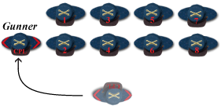

When the Chief of the Piece (Sergeant) is present, and not the instructor, he performs the duties
and takes the position (PLATE 2) of the gunner, who then posts 1 yard in rear (PLATE 1) of the right
file, and acts as file-closer, except when the chief of piece is out of ranks, then the gunner resumes
his post (PLATE 3).
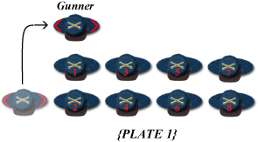
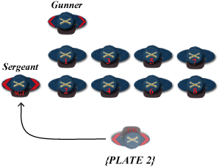

Movements of breaking and formation are first executed from a halt, that they may be better
understood. The men should change ranks every day, that they may become equally accustomed
to both, and each movement should be repeated by the left after being properly executed by the right.
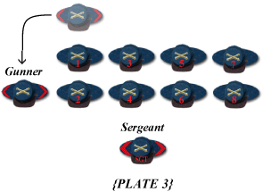

TO FORM THE DETACHMENT IN TWO RANKS.
The instructor commands:
1. Right into two ranks. 2. MARCH
3. Right DRESS. 4. FRONT.
At the first command the odd numbers take two steps to the rear (PLATE 4):
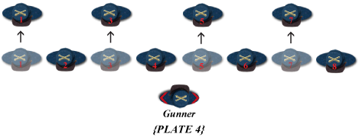

The even numbers face to the right, and at the command MARCH, move forward until opposite the
rear rank men of their files (PLATE 5), when they halt they will face front :
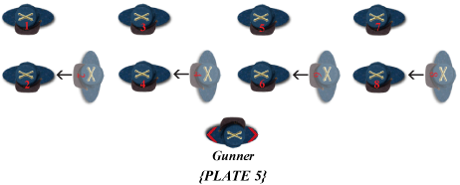

At the command Right DRESS (PLATE 6), the detachment is aligned to the right and FRONT.
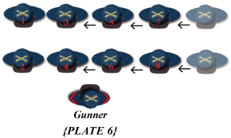

TO MARCH BY A FLANK.
When the detachment marches by a flank, (that is, when the men of each rank are formed in file,)
the even numbers are guides; they preserve the proper distance and keep in the direction of those
who proceed. The odd numbers touch lightly the elbows of their proper file leaders, and dress on
them. In the changes of direction, the man on the side towards which the turn is made executes it
as already prescribed; the man on the opposite side lengthens the step in turning, and keeps up
the touch of the elbow.
TO THE RIGHT OR LEFT (Below diagram shows TO THE RIGHT).
The detachment marching in line, the instructor commands:
1. Detachment by the right flank. 2. MARCH. 3. FORWARD.
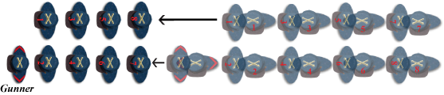

At the command MARCH, each man turns to the direction indicated, and steps off. The march
in line in the primitive direction is resumed at the commands:
1. Detachment, by files left. 2. MARCH. 3. FORWARD.
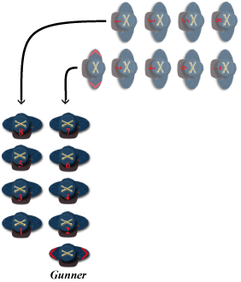

WHEELINGS.
There is but one wheel, that on a movable pivot. In wheeling, the pivot man describes an arc of
a circle, clearing the pivot 18 inches. The conductor of the marching flank lengthens the step as
much as possible, the others taking steps according to the positions they occupy, and touching
with the elbow towards the pivot. The conductor should measure with his eye the arc he is to
pass over, so that the files should not be to open nor too close. For this purpose he turns his head
occasionally towards the pivot; the cannoneers turn theirs slightly towards the marching flank,
to keep aligned, yield to pressure coming from the direction of the pivot, and resist that from the
opposite direction. When they have opened or closed too much, they will regain distances gradually.
The detachment being in line, at a halt, or in march, the instructor commands:
1. Detachment, in circle, right wheel. 2. MARCH.
At the command MARCH, the cannoneers take the wheeling steps. They turn the head slightly
towards the marching flank, taking care not to open or close the files too much, and to keep
aligned. The pivot man, clearing the pivot 18 inches, regulates himself on the marching flank.
The instructor sees that the men avoid all pressure in the ranks, and regulates the steps of the
different files. After several wheels have been executed, he commands:
1. Detachment --- HALT. 2. Left DRESS. 3. FRONT

TO WHEEL.
The detachment being in line, at a halt or in march, to place it in a position perpendicular to
the existing front, the instructor commands:
1. Detachment, right (or left) wheel. 2. MARCH.
3. HALT. 4. Left (or right) DRESS. 5. FRONT.
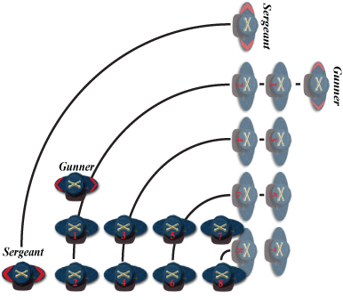
Which is executed as in the wheel in circle, the instructor giving the command HALT when the
wheel is nearly completed. In the wheel to the right, when the gunner is on the pivot flank,
he marks time in turning to the right on his own ground at the command MARCH.

TO OPEN AND CLOSE THE RANKS.
TO OPEN THE RANKS, the instructor commands:
1. To the rear in open order. 2. MARCH.
3. Right DRESS. 4. FRONT.
At the command MARCH, the rear rank briskly marches backwards 5 yards and halts, each cannoneer
accurately covering his file leader. At the command DRESS, the rear rank is aligned to the right.
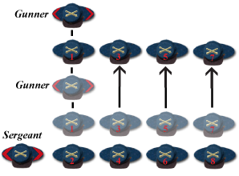

TO CLOSE THE RANKS, the instructor commands:
1. Close order. 2. MARCH.
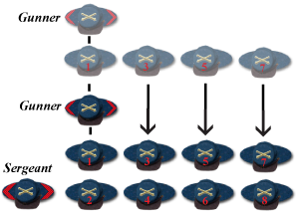
At the command MARCH, the rear rank closes on the front. After the foregoing movements
are properly executed with the sabers sheathed, they will be executed with drawn sabers. When
the ranks are closed, at the first part of the command Draw SABRE or Return SABRE, the rear rank
marches backwards 2 yards, and, after the movement is executed, closing again without a command.

OBLIQUE IN LINE.
The detachment marching in line, the instructor commands:
1. Cannoneers, right (or left) oblique. 2. MARCH.
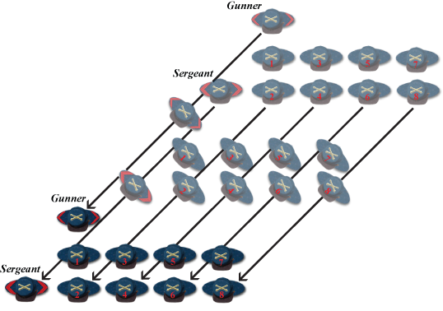
At the command MARCH, the cannoneers oblique in the direction ordered. The man of each rank
on the flank towards which the oblique is made is the guide of that rank, the guide of the rear rank
governing himself by that of the front. The other men, no longer keeping up the touch of the elbows,
glance towards their guide, and keep in such position that their shoulders may be in rear of those of
the next man of their rank in that direction.
The primitive direction is resumed at the commands:
FORWARD.
At this command, if the oblique has been properly executed, the detachment will move accurately in
line in its original direction. The guide reverts, without further orders, to the side on which it was
when the oblique was ordered: but the instructor may add the command Guide RIGHT, or Guide
LEFT, at his discretion.

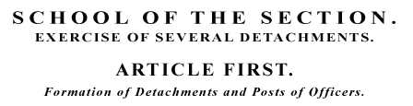
The gun detachments, properly told off, are drawn up in line corresponding to the positions of
their pieces in park, and touching each other. The cannoneers composing each of them retain their
numbers, and are kept in a fixed relation to each other when in rank and file formation; but the
detachment itself constitutes a unit. No notice is taken of inversions; the actual right and left
detachments being the right and left of the line, which may be formed from column by throwing
the rear detachment either to the right or left of the leading one.

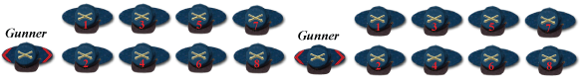
When the detachments are in line, the gunners are posted on the right of the front rank.

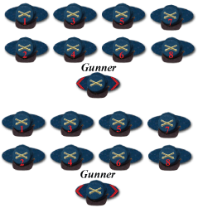
When in column, they are one yard in front of the center.

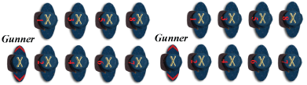
And when faced by flank, they are in their proper positions in the front rank.
When the chiefs of pieces are present, they act as gunners, the latter taking their place one yard in
rear of the right files of their respective detachments, and resuming their positions when the chiefs
of pieces are out of the ranks.

The officers, when present, are posted as follows:
CHIEFS OF SECTIONS.

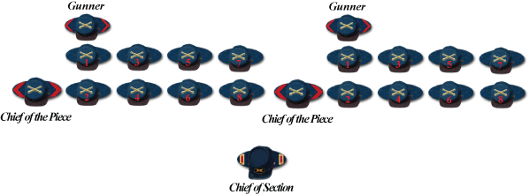
The section chief is in line, two yards in front.

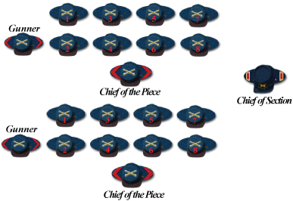
The section chief is in column of detachments, two yards outside the wheeling flank.

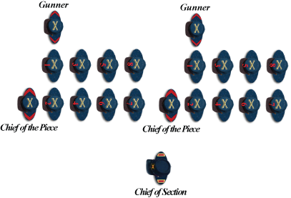
The section chief is by the flank, two yards from the front rank.
In all cases opposite the centers of their sections, except that when faced by flank the chief of the
leading section always marches at the side of the leading man.
THE CHIEF OF CAISSONS.
In line, four yards in rear of the center. In column, or by flank, four yards from the center of the
column, on the side opposite the chiefs of sections.

ALIGNMENTS.
The detachments are aligned by the instructor, at the commands:
1. Right (or left) DRESS. 2. FRONT

TO OPEN AND CLOSE THE RANKS.
To open the ranks, the instructor commands:
1. To the rear, open order. 2. MARCH
3. Right DRESS. 4. FRONT
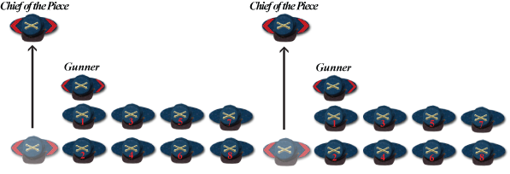
At the first command, the gunners step back briskly 5 yards, and halt opposite their places in line.

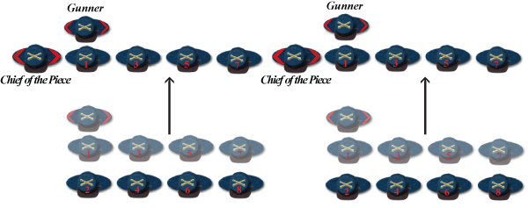
At the command MARCH, the rear rank briskly marches backwards 5 yards and halts, each
cannoneer accurately covering his file leader. At the command DRESS, the rear rank is aligned
to the right.

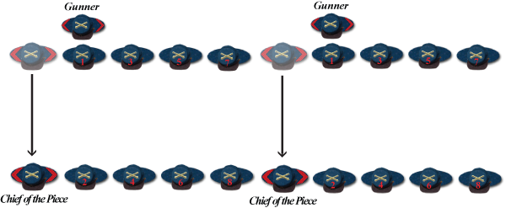
At the command FRONT, the gunners (or Chief of Piece) resume their positions in the front rank.
TO CLOSE RANKS, the instructor commands:
1. Close order. 2. MARCH
At the command MARCH, the rear rank closes on the front.

TO BREAK INTO COLUMN TO THE RIGHT OR LEFT.
The instructor commands:
1. By detachment, Right (or left) WHEEL.
2. MARCH 3. HALT
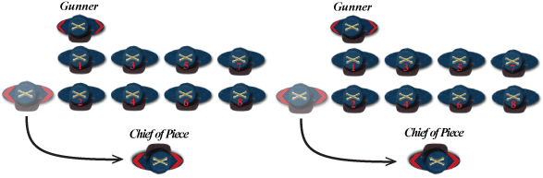
At the first command, the chief of the piece steps briskly one yard to the front of the center of their
detachments, face towards them and repeat the commands in succession after the instructor.

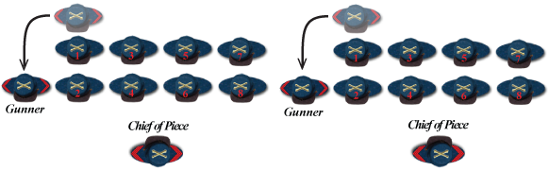
Immediately upon the chief of piece assuming his position in the front, the gunner resumes his post
to the right of the line.

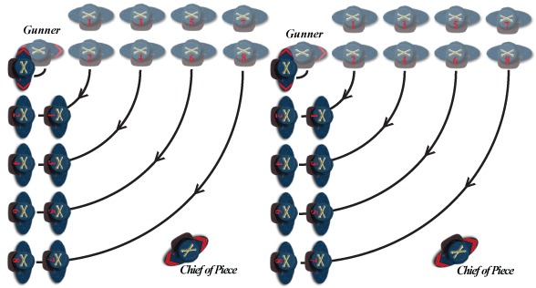
At the command MARCH, the cannoneers take the wheeling steps. They turn the head slightly
towards the marching flank, taking care not to open or close the files too much, and to keep
aligned. The pivot man, clearing the pivot 18 inches, regulates himself on the marching flank.

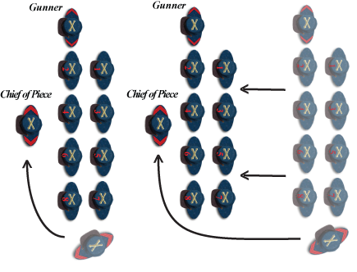
As soon as each detachment is halted, its gunner dresses it to the left, the guides covering each
other at distances equal to the front of a detachment, while the chief of the piece takes his place
in column. The line is broken into column to the left on the same principles.

MARCH IN COLUMN.
To put the column in motion, the instructor commands:
1. Column --- FORWARD
2. MARCH. 3. Guide left (or right.)
The commands FORWARD, MARCH and Guide left, are repeated by the gunners. The guide of each
detachment marches in the steps of the one preceding him, keeping his proper distance accurately.
The leading guide marches steadily to the front, in the direction given by the instructor.
When the instructor, after wheeling the detachments into column, wishes to put them in motion
without halting, instead of commanding HALT, he commands:
1. Column, FORWARD. 2. Guide left (or right.)
The gunner repeats the command FORWARD, and that for the guide.

TO HALT THE COLUMN.
The instructor commands: Column --- HALT.
The command HALT is repeated by the gunners.

CHANGE OF DIRECTION IN COLUMN.
The column marching, the instructor commands:
HEAD OF COLUMN TO THE LEFT.
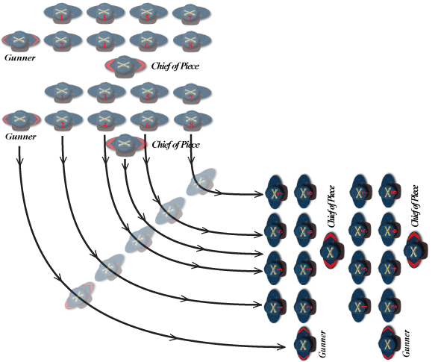
At this command, the chief of piece of the leading detachment wheels it to the left, and commands
FORWARD as the movement is completed. The other detachments wheel in succession on the same
ground as the first, and at the same commands from the gunners, the men taking care not to
commence the wheel until the command is given. To change direction to the right, the movement
is executed on the same principles.

TO MARCH BY A FLANK WHEN IN COLUMN.
The column marching, the instructor commands:
1. Column by the right(or left) flank. 2. MARCH.
3. FORWARD. 4. Guide left (or right.)
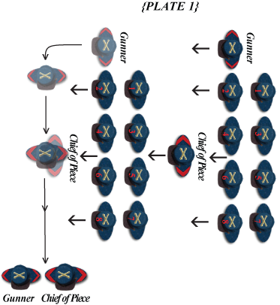
At the command, by the right (or left) flank, The Chief of the Piece and the Gunner steps off,
and takes their places (by the right or left flank) as the guides of their leading files.

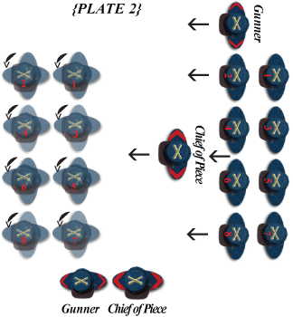
At the command, MARCH, repeat by the chiefs of piece, the entire detachment turns (left or right),
beginning with the lead cannoneers (Plate 2) and dress on the guides and preserve the intervals. The
officers face with the detachments, and maintain their relative positions. (Plate 3)
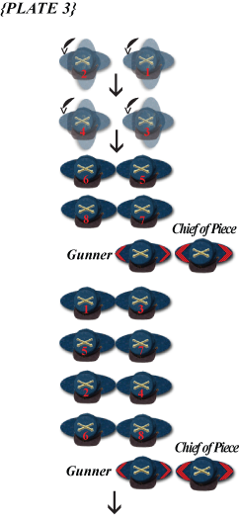

TO RESUME THE PRIMITIVE DIRECTION, the instructor commands:
1. By the left (or right) flank. 2. MARCH
3. Column forward. 4. Guide right (or left.)
At the command MARCH, the detachments face as directed. The chief of pieces repeat the
commands, and resume their places in column.

COLUMN RIGHT OR LEFT FLANK, BY FILES RIGHT-OR-LEFT
The column marching (below), the instructor commands:
1. Column by the right flank, by files right. 2. MARCH.
3. FORWARD. 4. Guide left (or right.)
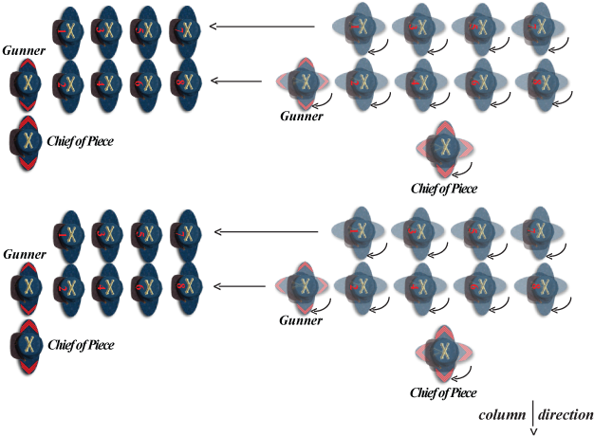
At the command MARCH, repeat by the chiefs of piece, the detachments do a left face and continue the march.
The chiefs of piece take their places at the sides of their leading files, dress on the guides and preserve
the intervals. The officers face with the detachments, and maintain their relative positions.

OBLIQUE MARCH IN COLUMN.
The column marching, the instructor commands:
1. Cannoneers right (or left) oblique. 2. MARCH.
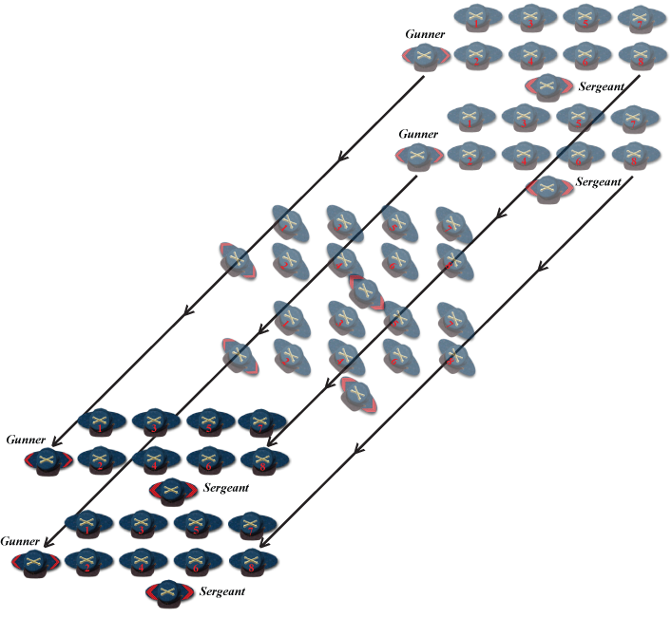
The sergeants repeat the commands in succession after the instructor, and each detachment
oblique’s each rank on the flank towards which the oblique is made is the guide of that rank, the
guide of the rear rank governing himself by that of the front. The other men, no longer keeping
up the touch of the elbows, glance towards their guide, and keep in such position that their
shoulders may be in rear of those of the next man of their rank in that direction.
The guide of the front rank of the leading detachment is the guide of the column. The other
guides move in the same direction and keep on a line with him, so that at the command FORWARD,
they will cover each other accurately at proper distances.

Battery Formation, into Column
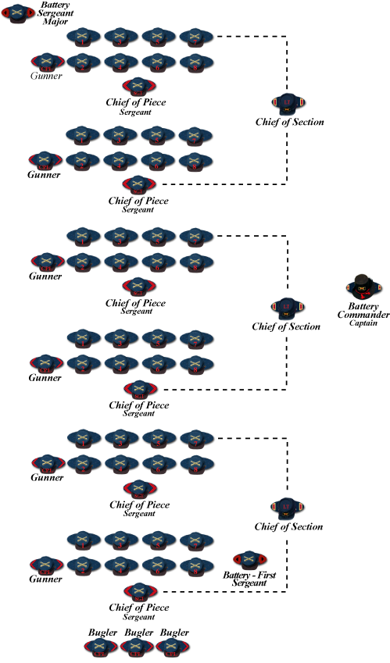

Battery in Line, Sections into Column Formation
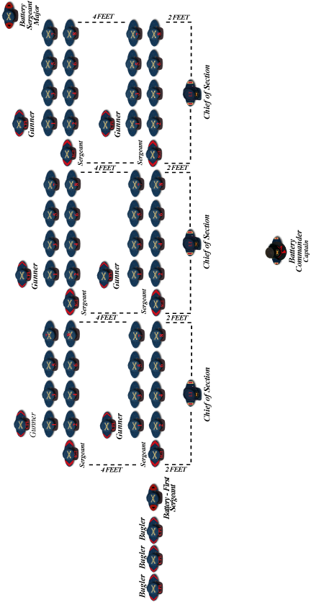

Battery Formation, into Line
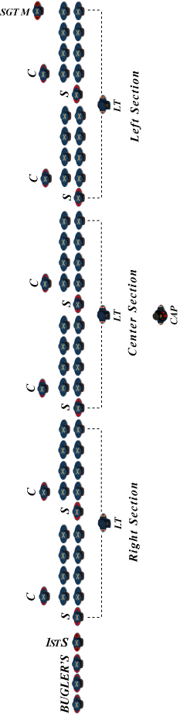

Brigade Formation, Battery’s into Columns
